IMMC 2021 1st Mini-Project—Rating System to Rate the Math Level of Students
Team: Justin, Ryan, Joyce, Letitia

- Assumptions and Justifications

Assumption 1: The students who are chosen to be rated through the rating system are all in math H level.
Justification: This factor can make the diagram easier to understand because the students who will be rated are all on the same level, therefore lessening the variables that need to be considered.

Assumption 2: The students who are chosen to be rated have all only participated in one test between AMC 8 and AMC 10.
Justification: With this factor, the produced rating system can be simpler and easier to navigate. Furthermore, it will serve to make the system fair and not incline towards the students who have participated in two or more AMC tests.

Assumption 3: The number of midterms and finals taken by the math H-level students are both 2.
Justification: This will ensure that the final result will not be impacted by the varying number of tests that different students might have taken. Since the final score will be higher with the more test scores that it will add onto, limiting the number of tests that the students have taken will also make the system fairer.

- Variables
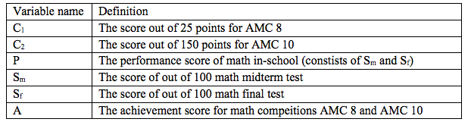

- Math Level Rating System

The math level rating system will be consisting of two parts: performance in-school and achievements in math competitions AMC 8 and AMC 10. The scores of math midterm and final tests make up the performance in school. On the other hand, the scores of the AMC 8 and AMC 10 make up the achievements in math competition.
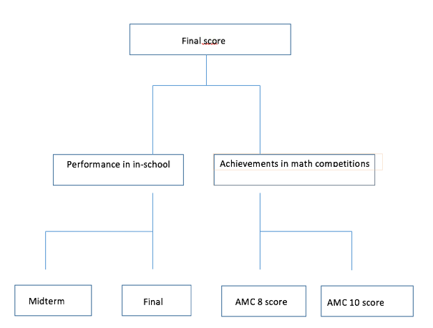
Math midterm and final scores are two independent scores that make up all of the performance in school; they are also both out of 100. Therefore, we choose to use addition directly to get the performance in-school part of the rating system.

P = S_{m +} S_{f}

Competition AMC 8 and AMC 10 are also two independent scores that make up of all the achievements in math competitions; however, AMC 8 is out of 25 points while AMC 10 is out of 150 points. Directly adding the two will make AMC 8 being part of a smaller percentage. So, to make AMC 8 scores being an equal amount to AMC 10 scores, we decided to multiply 6 to the AMC 8 scores. This will make AMC 8 taking up same percentage of AMC 10.
Rating System to Determine Different H-level students’ Math Level

A = 6C₁ + C₂

To create the final rating score, the performance score and achievement score are added.

- Strengths:
- With this rating system, we are able to calculate and compare the final results by the means of rating system in a systematical and fair way through adding the scores with equivalent total points and also by considering factors and scores of the student both in and outside of class.
- The rating system processes out a numerical outcome as the result, which causes comparisons of results and management of data (e.g., finding the mean, median, mode, and range) more convenient

- Weaknesses:
- Some students might only review for one or none of the competitions, which might drag down their final score. Not reviewing can limit a student’s true potential and will therefore make the results inaccurate.
- Other factors that are not related to the student’s academics, such as competition experience, can also affect the rating system’s final result.

